Project Design Phase-II
Data Flow Diagram & User Stories

Date | 26 June 2026
Team ID
Project Name | Leave Approval System
Maximum Marks | 4 Marks

Data Flow Diagrams: A Data Flow Diagram (DFD) is a traditional visual representation of the information flows within a system. A neat and clear DFD can depict the right amount of the system requirement graphically. It shows how data enters and leaves the system, what changes the information, and where data is stored.
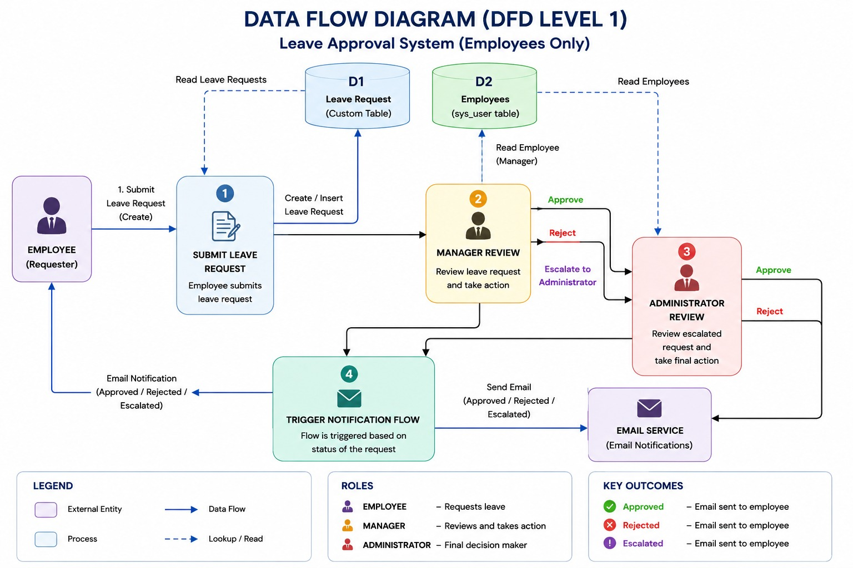

User Stories
Use the below template to list all the user stories for the product.
User Type | Functional Requirement (Epic) | User Story Number | User Story / Task | Acceptance criteria | Priority | Release
Employee | Login | USN-1 | As an employee, I can log in to the Leave Approval System using my credentials. | Employee can successfully log in to the system. | High | Sprint-1
Employee | Leave Request Submission | USN-2 | As an employee, I can submit a leave request by providing leave details and reason. | Leave request is successfully created and stored. | High | Sprint-1
Manager | Leave Approval | USN-3 | As a manager, I can review pending leave requests and approve or reject them. | Manager can approve or reject requests successfully. | High | Sprint-2
Employee | Email Notifications | USN-4 | As an employee, I receive an email notification when my leave request is approved or rejected. | Employee receives the correct email notification. | High | Sprint-2
Employee | Leave Status Tracking | USN-5 | As an employee, I can view the current status of my leave requests. | Employee can see Pending, Approved, or Rejected status. | Medium | Sprint-3
Administrator | User Management | USN-6 | As an administrator, I can manage employee and manager access to the system. | Users are assigned the correct roles and permissions. | Medium | Sprint-3
Administrator | Leave Records | USN-7 | As an administrator, I can view and maintain all leave request records. | All leave records are stored and accessible. | Medium | Sprint-3
Manager | Dashboard | USN-8 | As a manager, I can view a dashboard of pending and processed leave requests. | Dashboard displays accurate leave request information. | Low | Sprint-4

